4 May 2007 The Weekly Bulletin of Rotary Club of Kathmandu Mid-Town Bc # 44 of 2006-07
Rotary Club of Kathmandu Mid-Town
Breakfast Chatter




District : 3290 Web: www.rotarymidtown.org.np Club Id : 26776

MAY IS THE DISTRICT MONTH
All districts are required to have established a leadership plan in conformity with the District Leadership Plan (DLP) structure outlined by the Board. The DLP is designed to strengthen Rotary at the district and club levels by making possible faster and more responsive support for clubs, a larger supply of well-trained district leaders, a larger field of candidates for district governor, improved participation in Foundation and district activities, ability to manage over 100 clubs effectively, and better communication within the district.

Mr Mangal Man Shakya, environmental journalist, coordinator/chairman of Wildlife Watch Group (WWG) talked on illegal trade in wildlife parts at the Club meeting on Friday, 27 April 2007.
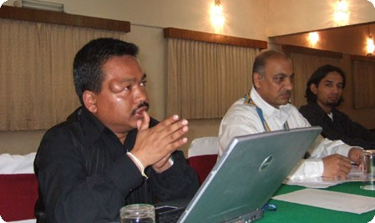
a) Guest Speaker Mangal M Shakya answering questions put forward by Club members
while President CK Golchha listens to.

Weekly Meetings and Programs :
Date | Program/Speaker | Program/Topics of Presentation
4 May 2007 | Dr Dwarika N Dhungel | Governance in the working of political parties
11 May 2007 | Gyanendra Lal Pradhan | Hydropower
18 May 2007 | Basant Kunwar

Friday, 4 May :
Dr Dwarika N Dhungel, former Executive Director of and currently Senior Researcher at the IIDS (Integrated Institute for Development Studies), will be talking on the elements of governance in the working of political parties - the four major parties covered in his study – focused on their modus operandi, framework, challenges, opportunities and suggested future courses of action.
President CK handed over a check of Rs. 40,000 to Mr. Dharma Lal Shrestha, Headmaster of Janata Primary School in Tistung at the Club meeting on 27 April 2007.
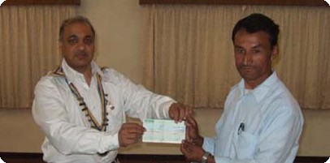

Club Picnic :
Mid-Towners who went to a picnic on Saturday, 28 April 2007 with their spouses and children had a wonderful day at picnic venue located at the Proposed Rotary Peace-Park site near SKM Hospital, Sankhu.
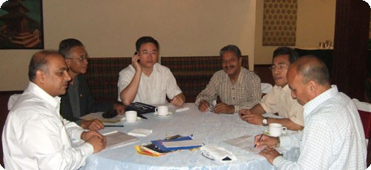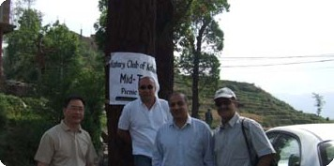
Planning picnic program and activities On the way to Picnic Site
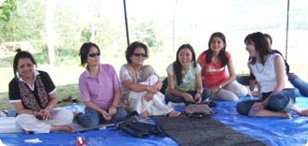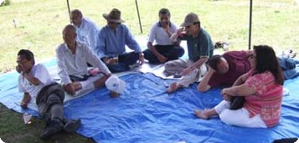

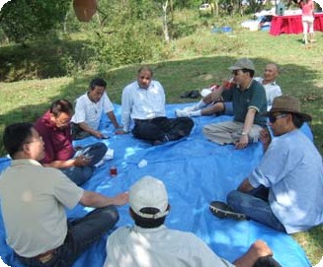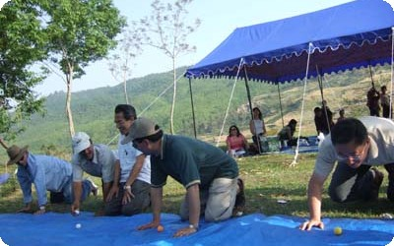

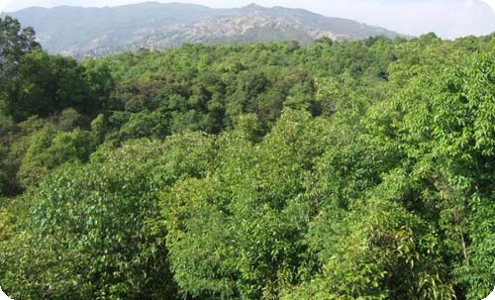

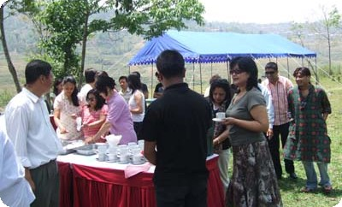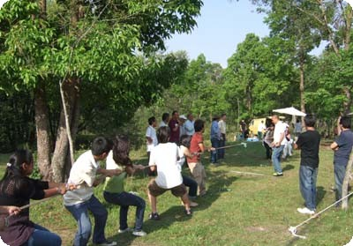

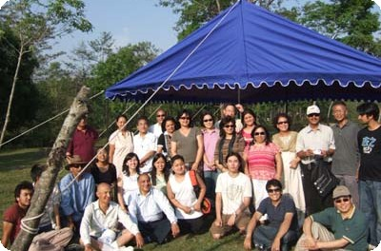
Group photo before dismantling tents and departing.

On Lighter Side : Click at the figure ⇩


Khalil Gibran wasn’t thinking of Rotary when he wrote: “You give but little when you give of your possessions. It is when you give of yourself that you truly give.” Yet these are perfect words to apply to the pleasure we experience in giving to our Rotary Foundation and doing our humanitarian work as Rotarians
RI President William B. Boyd

4 May 2007 The Weekly Bulletin of Rotary Club of Kathmandu Mid-Town Bc # 44 of 2006-07

Editor: RR Shrestha, Club Service Director email: rryes@wlink.com.np

